# GLAB 330.2.2 - Standard Deviation

# 

**Introduction:**

**Standard Deviation** **(*σ*)** in statistics, typically denoted by **σ**, is a measure of how much a data set varies (dispersion) between values in a set of data. The lower the standard deviation, the closer the data points tend to be to the mean (or expected value), **μ**. In this lab, we will demonstrate how to calculate the standard deviation.

## Learning Objective:

By the end of this lab learners will be able to calculate the standard deviation.

**Given Dataset**

Imagine that we have the following data set representing the number of books read by five learners in a month:

|  |
| --- |
| **Number of Books (X)** |
| 2 |
| 4 |
| 4 |
| 4 |
| 5 |
| 5 |
| 7 |
| 9 |

Number of Coffee Shop Visits per Month by 8 Different Students:

|  |
| --- |
| **Number of Coffee Shop Visits (X)** |
| 3 |
| 5 |
| 6 |
| 8 |
| 7 |
| 9 |
| 6 |
| 12 |

**Instructions:**

Here are the steps to calculate the standard deviation:

1. **Calculate the mean (average) of the data set:**



(3+5+6+8+7+9+6+12) = 56 / 8 = 7

1. **Calculate the squared differences from the mean for each data point:**

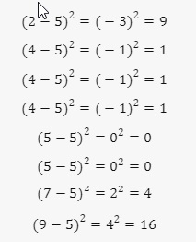

**(3-7)2= (-4)2 = 16**

**(5-7)2 = (-2)2 = 4**

**(6-7)2 = (-1)2 = 1**

**(8-7)2 = (1)2 = 1**

**(7-7)2 = (0)2 = 0**

**(9-7)2 = (2)2 = 4**

**(6-7)2 = (-1)2 = 1**

**(12-7)2 = (5)2  = 25**

1. **Calculate the average of these squared differences (variance):**

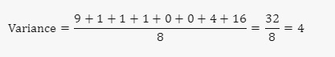

**16+4+1+1+0+4+1+25 = 52 / 8 = 6.5**

1. **Take the square root of the variance to get the standard deviation:**

## 

√6.5 = 2.55

The standard deviation of the number of coffee shop visits by these students is **2.55**. This means that on average, the number of coffee shop visits by each student deviates from the mean by **2.55 visits**.

**Canvas Submission Instructions:**

* Upload your project to your GitHub account without setting it to private.
* Utilize the `README` file for any necessary additional instructions.
* Incorporate suitable comments throughout your project.
* Share the GitHub link on Canvas by clicking on the "Start Assignment" button located in the top-right corner of the Assignment page.